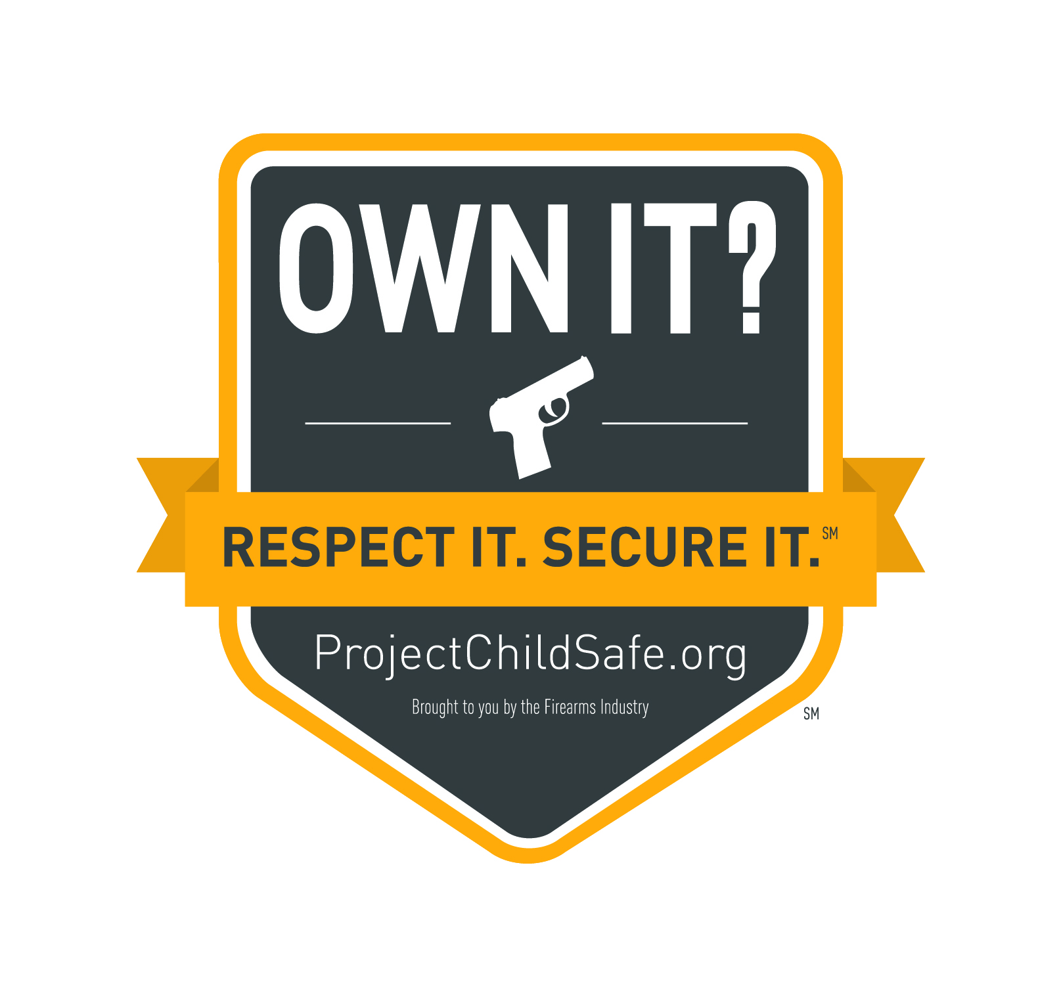
Sample Social Media Content
_____________________________________________________________________________________

Sample Facebook posts
- We are proud to announce that [Company Name] is a supporter of the Own it? Respect it. Secure it. Initiative. Remember to store your firearms responsibly when not in use! [ORS badge]
- Our industry is united in advocating responsible firearm ownership throughout the country. Our message to gun owners: Store your firearms responsibly. [ORS badge]
- Did you know safe firearm storage is the #1 way to help prevent firearms accidents? Remind gun owners to store their firearms responsibly. [ORS badge]
- Along with the @National Shooting Sports Foundation and supporters across our industry, we urge you to store your firearms responsibly. [ORS badge]
- The firearms industry is united on firearm safety and responsibility. We urge gun owners to store their firearms responsibly. [ORS badge]
- We are proud to join the @National Shooting Sports Foundation in its commitment to safe and responsible firearm storage and handling. Join the Own it? Respect it. Secure it. Initiative: [Link to initiative]
- [Company Name] is proud to stand behind @National Shooting Sports Foundation’s Own it? Respect it. Secure it. Initiative. Help us spread the message: Store your firearms responsibly

Sample Tweets
- [Company Name] is part of Own it? Respect it. Secure it. Initiative & reminds you to store your firearms responsibly when not in use!
- [Company Name] reminds you: store your firearms responsibly.
- Our message to gun owners: Own it? Respect it. Secure it.
- The #1 way to help prevent firearms accidents? Safe and responsible storage. RT to show your commitment
- Along with @NSSF and supporters across our industry, we urge you to store your firearms responsibly.
- Our industry is united on firearms safety. We urge gun owners to secure their firearms responsibly.
- We’re proud to join @NSSF in commitment to responsible firearm storage. Join the Own it? Respect it. Secure it. Initiative: [link to initiative page]

Potential Hashtags
- #ProjectChildSafe
- #OwnitRespectitSecureit
- #ORSfirearms
- #ORSsafety
- #TeamORS
- #FirearmsResponsibly
- #SecureFirearms
- #LockitUp

