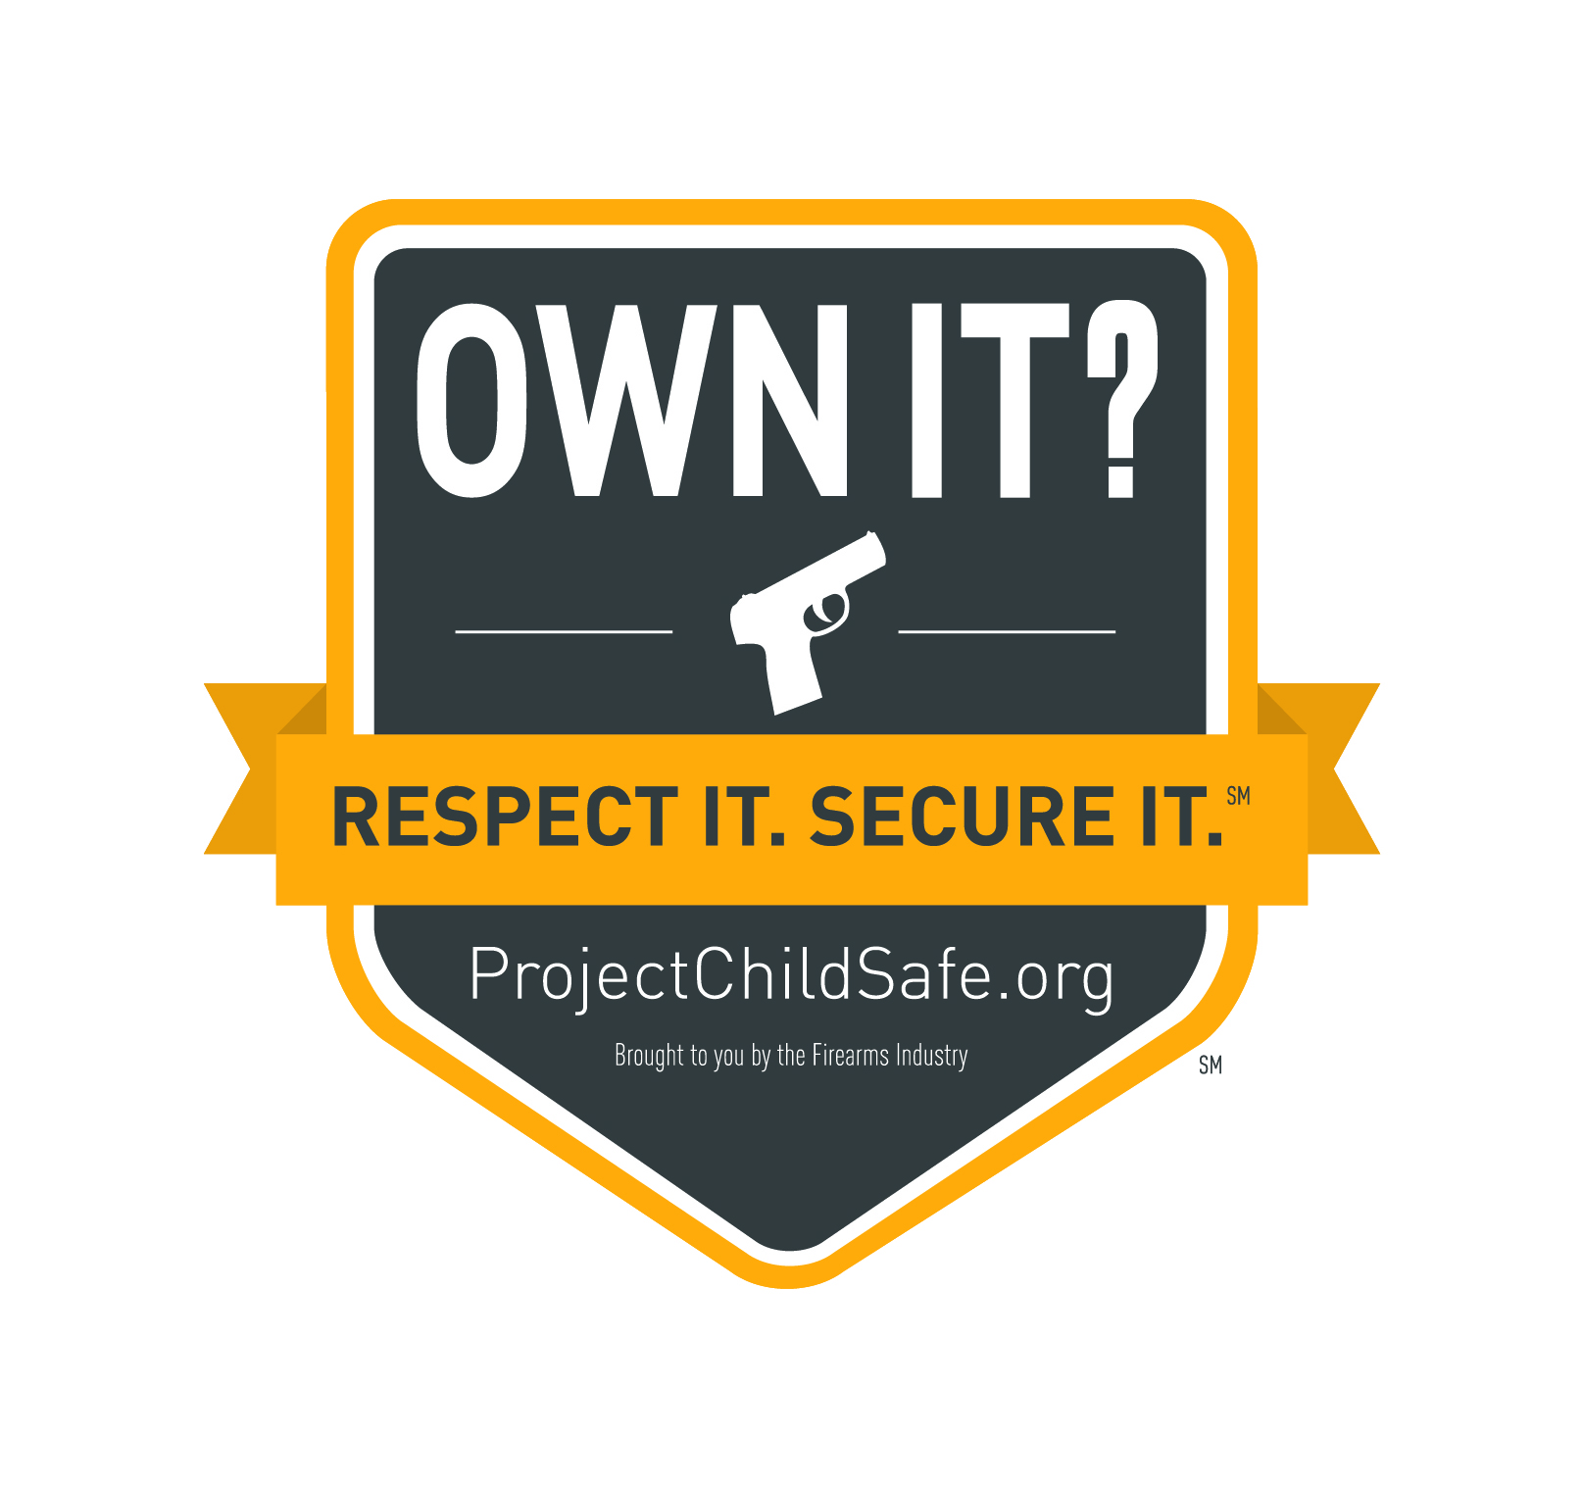
Template ORS LTE
_____________________________________________________________________________________

Word Count: 165

Own it? Respect it. Secure it. Putting these words into action is a simple and powerful way to help prevent firearm accidents and unauthorized access to firearms. That’s why we are proud to be part of the Own It? Respect It. Secure It. (ORS) InitiativeSM and committed to spreading this message every way we can to our customers/community/members.(Add in what you are doing to promote the Initiative…).

Without question, safety should always be top of mind when handling firearms. Safety when firearms are not in use is just as important. In fact, we want the safe storage of firearms when not in use to become second nature, like keeping medicine in child-resistant containers.

The more we repeat this message the more firearms owners will be reminded to take important yet simple steps to securely store their firearms when not in use.

We encourage you to share this message with your friends and family. And for more information on the ORS Initiative, please visit www.nssf.org/ORS.

