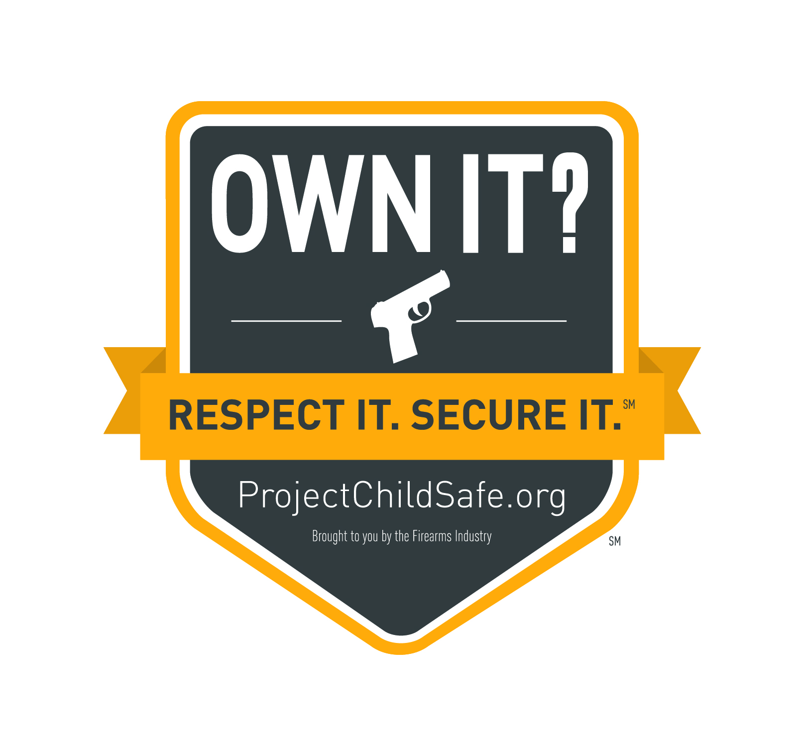

[Organization] Joins Push to Encourage Firearm Owners to Own It? Respect It. Secure It.

[Organization] to generate firearm storage awareness by… list activity here
[Town, State] – [Organization] today announced its involvement in the Own It? Respect It. Secure It. (ORS) InitiativeSM to help raise the public’s consciousness on the issue of firearm safety and responsibility through the core message: “Store Your Firearms Responsibly.” To generate awareness around this important message, [Organization] has/will: (describe organizational activities to support the initiative here…
“Through the ORS Initiative, we want to reach as many people as possible with this message to encourage safe and responsible firearm storage,” said XXX, of [Organization]. “Our goal is to make proper firearm storage as second nature as keeping medicine in child-resistant containers. And with the ORS Initiative, we can have a positive impact in helping to prevent accidents and unauthorized use of firearms.”
The ORS Initiative, created by the National Shooting Sports Foundation, is built on the firearm industry’s long-standing commitment to safety and has been developed to give industry members an ongoing platform to promote and encourage firearm safety and storage. It also serves to enhance and amplify the messages of ongoing safety and education campaigns such as Project ChildSafe®, which has distributed more than 36 million free firearm safety kits to gun owners through partnerships with law enforcement agencies in all 50 states and five U.S. territories
“Storing your firearms responsibly is a simple but vitally important message, and we are pleased to have [Organization]’s support for this Initiative,” said Steve Sanetti, NSSF president and CEO. “Together with all our industry partners we can be powerful messengers in encouraging firearm owners to respect their firearm and store it responsibly when not in use.”
In the coming weeks and months, consumers and participants in the shooting sports will begin seeing the ORS message in brochures, on packaging, in advertising, social media and at retail counters.
For more information on the ORS Initiative, please log on to: www.NSSF.org/ORS

About [Organization]
Company boilerplate goes here
About NSSF
The National Shooting Sports Foundation is the trade association for the firearms industry. Its mission is to promote, protect and preserve hunting and the shooting sports. Formed in 1961, NSSF has a membership of more than 10,000 manufacturers, distributors, firearms retailers, shooting ranges, sportsmen's organizations and publishers. For more information, log on to www.nssf.org.
###

